**Riyadh House prediction**

**Linear regression project**

**Ebtesam Sultan - Nuha Aljohani**

## **Abstract**

## The goal of this project is to build a regression model to predict sale prices for houses in Riyadh .

## **Data Description**

* We scrpined our data set from Aqar website with 1575 rows and 6 columns .
* The Columns include (Location , Price , Size , Bed , Bath and link ) .
* Data Type :String -Integer .
* Data set hasn’t null values .

## **Tools**

* **Technologies**: Python, Jupyter Notebook, PowerPoint
* **Libraries**: Pandas, NumPy, Matplotlib, Seaborn , Requests, BeautifulSoup, Sklearn

## **Communication:**

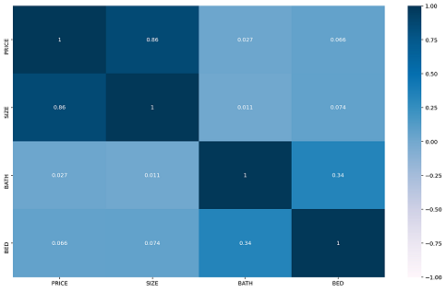

* The figure represented in heatmap plot , the above figure shows the relations between the features in range between -1 to 1
* 1- the plot show that price has a correlation with size
* 2- the plot show that rooms and bath has a lower correlation with price

## **Experiments :**

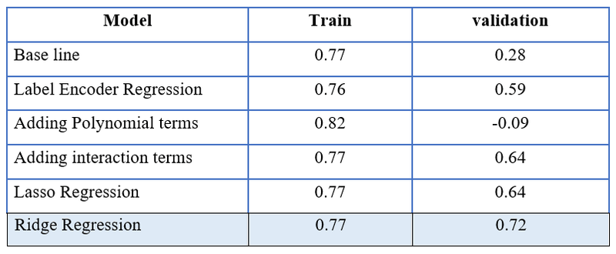

* We noticed during the project, that model Ridge Regression gave us the best results among the models .
* Ridge Regression model can help the real estate companies to predict Riyadh housing prices .